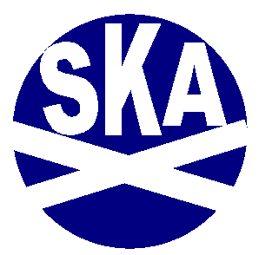
Scottish Karate Alliance
President: Sensei Bill Hair, 6TH Dan Shotokan 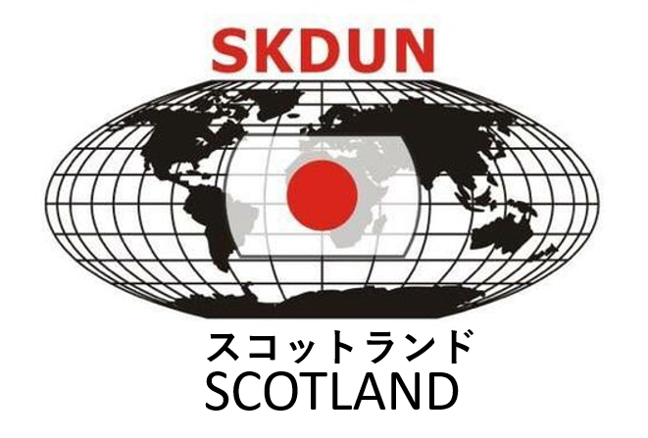 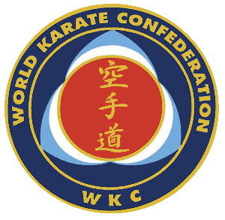
Referee Commission World Karate Confederation
WORLD KARATE CONFEDERATION (WKC)
SHOTOKAN KARATE-do UNITED NATIONS (SKDUN )
NATIONAL ASSOCIATION of KARATE & MARTIAL ARTS SCHOOLS
E mail billhair72@gmail.com / +44(0)7979222986

SATURDAY 29TH June

SPORT SCOTLAND INVERCLYDE NATIONAL SPORTS CENTRE
BURNSIDE ROAD
LARGS
KA30 87RW

12.7.23

Dear Sensei ,

I am writing to invite yourself and your group to attend the 25th Scottish Karate Alliance Open Championships which will be held ,for the third time at Inverclyde National Sports Centre ,Largs on Saturday 29th June 2024.

This is a traditional karate event ,with kata ,team as well as individual ,and shobu-ippon and shobu-sanbon kumite again for individuals as well as teams .

The rules will be under World Karate Confederation banner , which are almost identical to , Shotokan Karate-do of United Nations , Japan Karate Association , Japan Shotokan Karate Association ,World Union of Martial Arts Federation ,KUGB and all other traditional world bodies .

There will be specially made Olympic style medals for the first three competitors in both kata and kumite ,with kumite having a joint third place medal .

I hope you will add our event to your calendar ,as it is my opinion that there are not nearly enough open events for traditional karate-ka to meet ,practise and develop there skills outside there own national and international events.

For accommodation and any transfer from airport or hotel to the venue please contact craighume@thornetravel.com Thorne Travel Team
153 Main Street | Kilwinning | KA13 6EQ | Scotland | ABTA L6099
T: +44 (0) 1294 559949 | E: enquiries@thornetravel.com
www.thornetravel.com | Facebook | Twitter

Yours sincerely

Bill Hair 6th Dan Shotokan 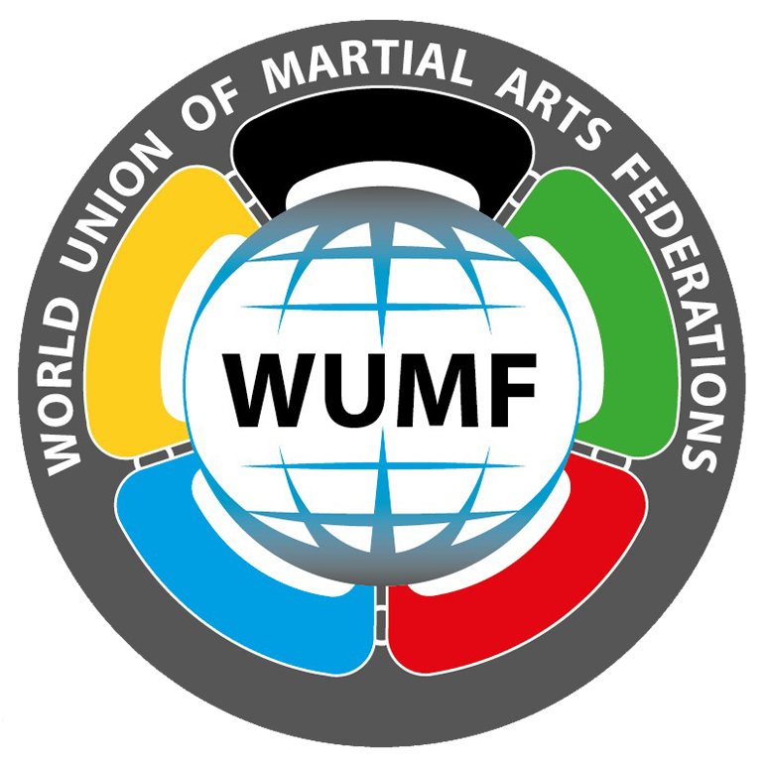
Member of Referee Commission World Karate Confederation & World Union of Martial Arts Federation

